1. Write the spring boot for login application. Database will have USER table and it will have the list of userids and passwords. Users credentails will be validates against this data. Data to the controller should be sent using POST method. This application should be tested using POSTMAN.

MAIN CLASS

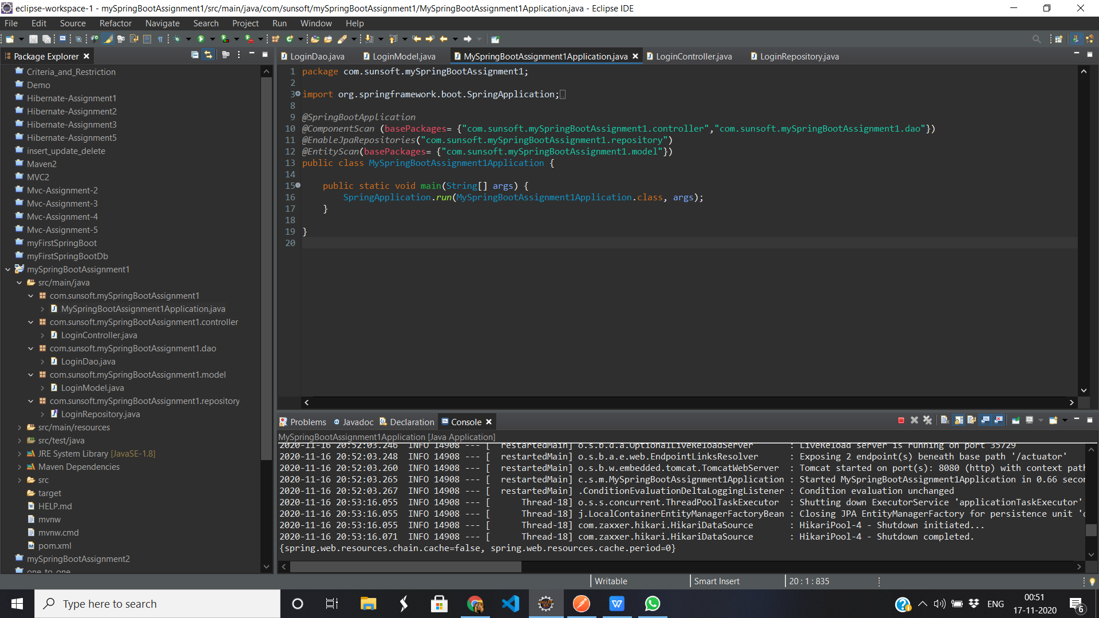

Login POJO

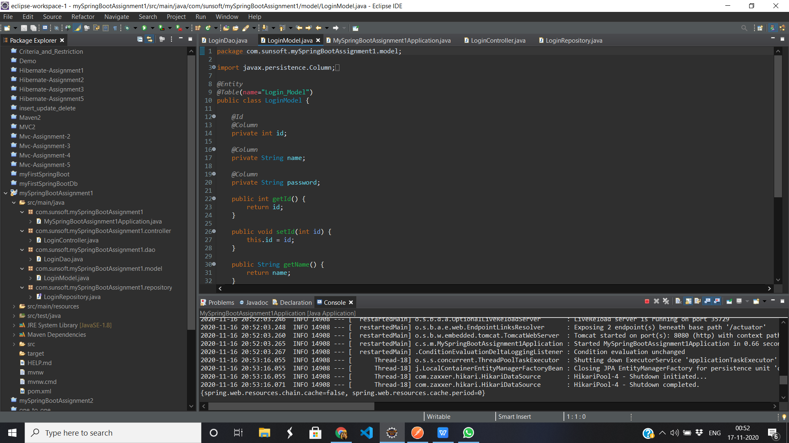

Dao Service

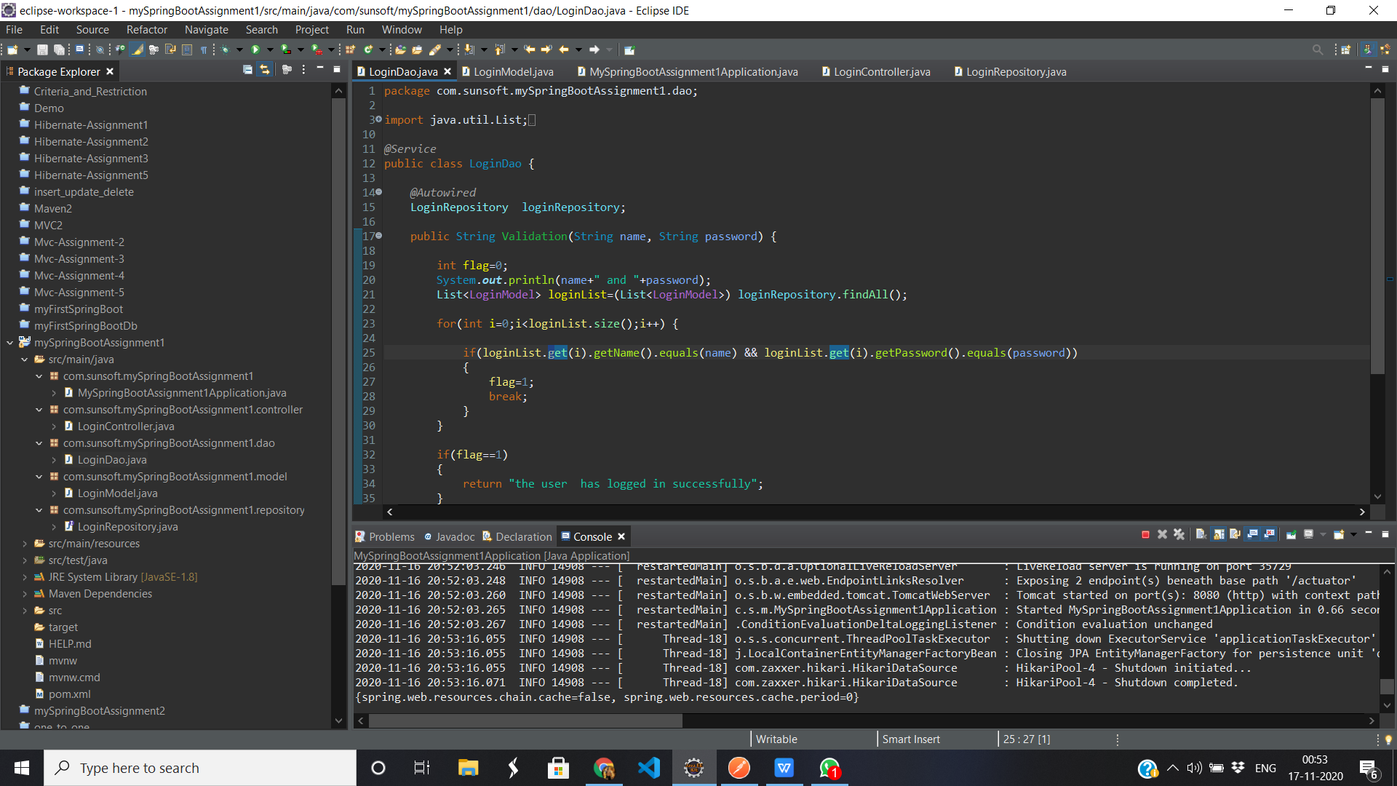

Login Controller

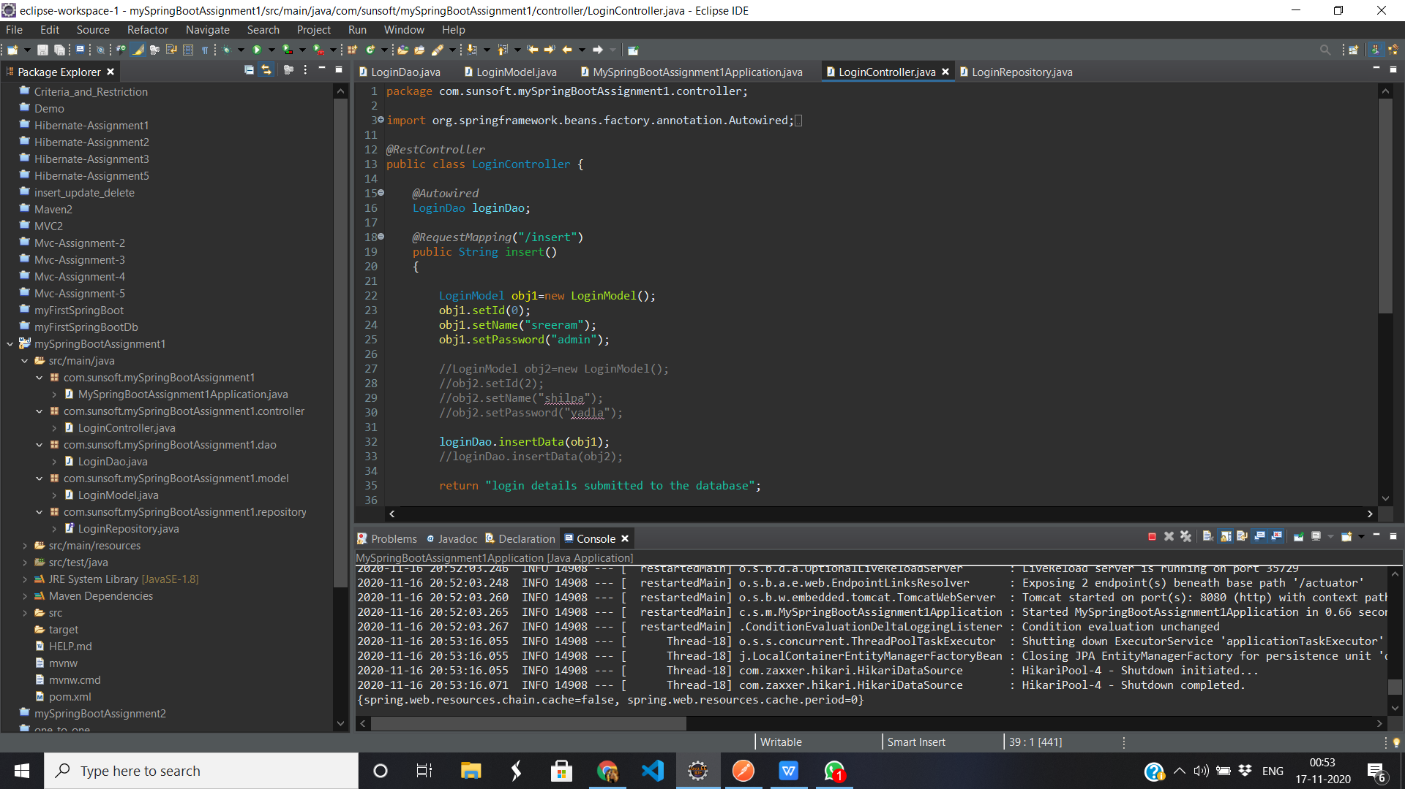

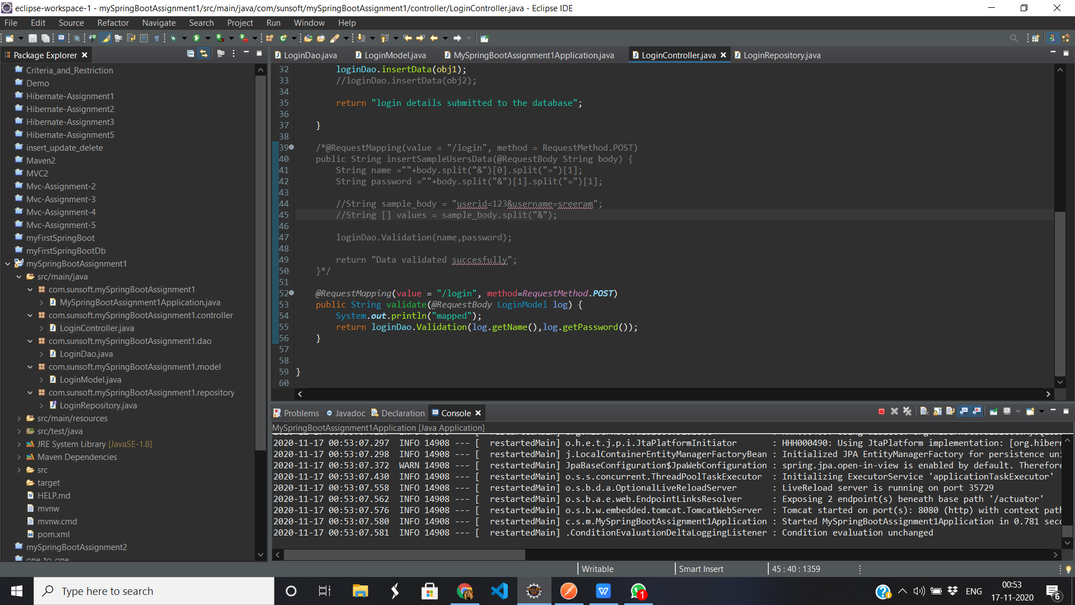

PostMan

